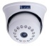
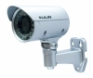
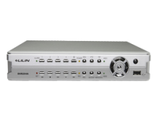
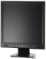
Indoor Camera Outdoor Camera DVR / NVR Monitor

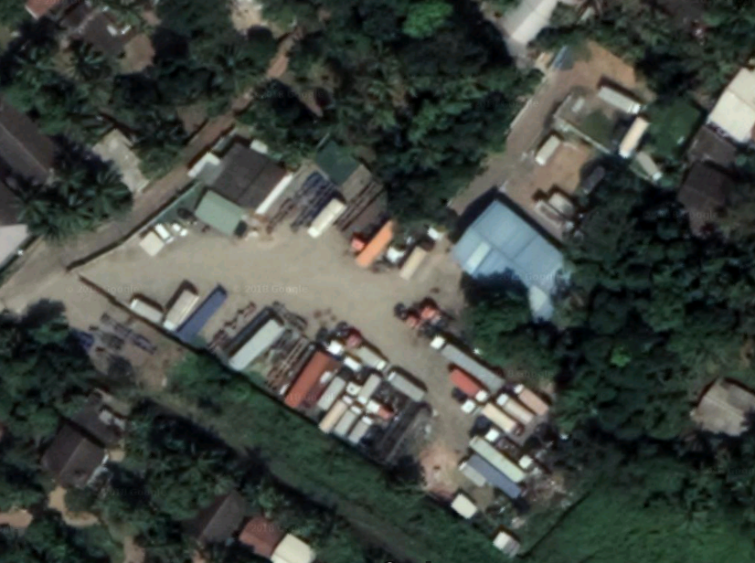
NVR
Entrance

Data uplink

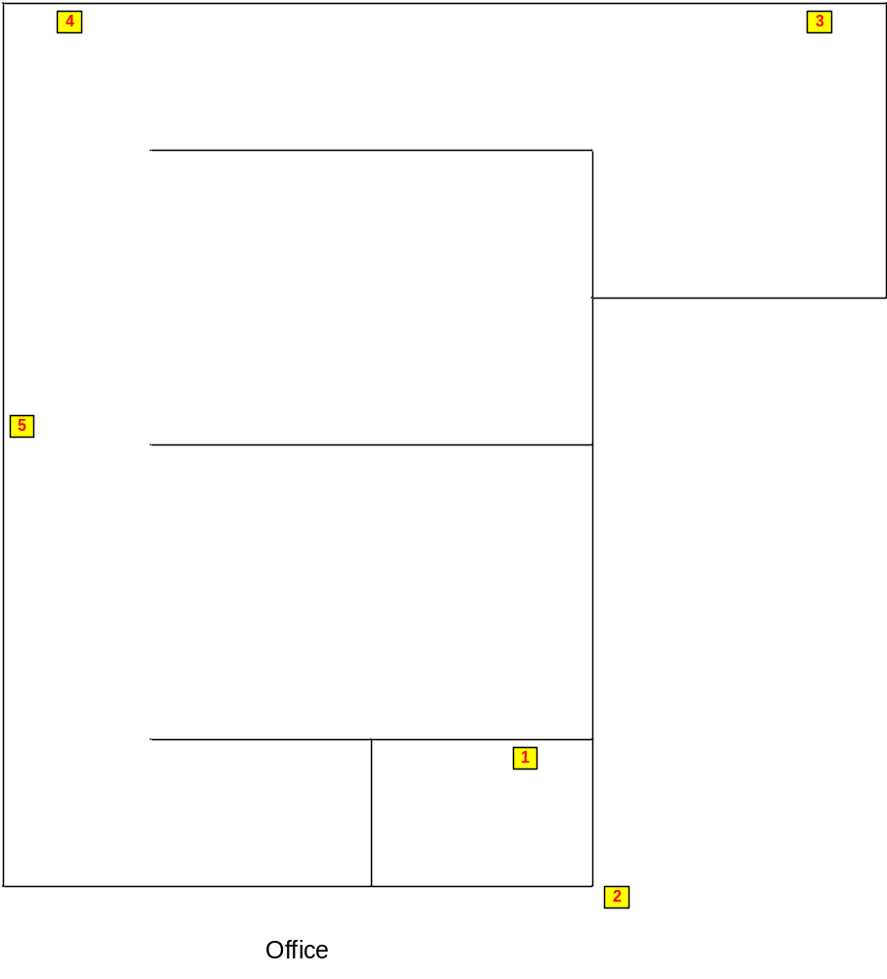

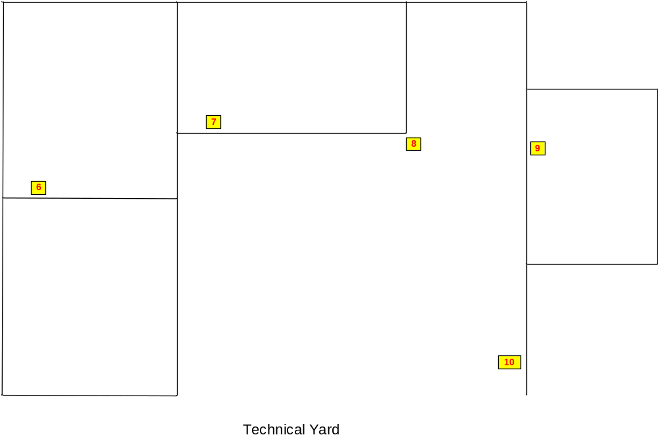
Customer Name | Freight Links International
Drawing Title | CCTV System
Issue No | RE/TE/04012018
Issue Date | 04/01/2018
Revision No
Revision Date
Created By
Approved By

